Postprocessor User's Guide for Kuraki KBT

Kuraki KBT is a 4-Axis Milling Machine.

In order to use this postprocessor correctly, you should follow the instruction below.

1. UDE setting for quill-table positioning
Add Set Axis UDE to the operation or program group in the program order view. Set Axis to the axis you want to positioning.
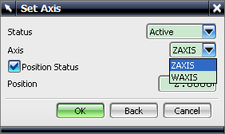
Input the position value to the place with Position label.
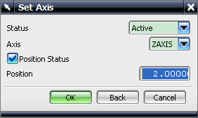
After add this UDE to the operation or program group in the program order view, the corresponding axis output mode will be set to this operation or group.

